EXP.NO: 6 | Write a Servlet to demonstrate session tracking using HttpSession.
DATE:26/03/2025

AIM:
To demonstrate session tracking using HttpSession in a Servlet-based web application. The exercise involves implementing a simple login system where a user can log in with their username and password, and their session will be tracked throughout their interaction with the web application.
ALGORITHM:
1. Input:
- The user will enter their username and password in a login form.
- The servlet will validate the credentials and create an HTTP session for the user if authentication is successful.

2. Steps for Implementing Session Tracking with HttpSession:
- Create the Login Form (HTML):
  - Create an HTML form with two input fields for username and password.
  - Provide a submit button to send the data to the servlet for authentication.
- Create the Login Servlet:
  - Write a Java servlet class to handle login requests.
  - The servlet will:
    - Retrieve the username and password from the form.
    - Authenticate the user by comparing the credentials to a stored value (e.g., hardcoded or from a database).
    - Create a new HTTP session for the user if the credentials are valid.
    - Set session attributes such as the user's username to track the session.
- Validate User Credentials:
  - In the servlet, check if the username and password match the expected values.
  - If valid, create a session and store the username in the session.
  - If invalid, redirect the user back to the login page with an error message.
- Create and Track User Session:
  - Upon successful login, use the HttpSession object to store the session data.
  - Use the session.setAttribute("username", username) method to save the username.
  - Optionally, set session timeout using session.setMaxInactiveInterval(time_in_seconds) to manage session expiration.
- Redirect to a Protected Page:
  - After a successful login, the user will be redirected to a protected page (e.g., a dashboard or home page).
  - The protected page should check if the user is authenticated by checking the session attribute.
- Logout and Session Invalidation:
  - Provide a logout feature that invalidates the session using session.invalidate() when the user logs out.
  - After logout, redirect the user back to the login page.
- Session Expiration:
  - If the session expires or the user manually logs out, the session will be invalidated, and the user will be redirected to the login page.
Code:

index.html (Login Page)

<html>

<head>

<title>Online Result Collector Login</title>

<style>

body{

margin:0;

font-family:Arial;

background:linear-gradient(135deg,#2563eb,#0f172a);

display:flex;

justify-content:center;

align-items:center;

height:100vh;

color:white;

}

.box{

background:#111827;

padding:30px;

border-radius:12px;

text-align:center;

width:320px;

}

input,button{

width:90%;

padding:10px;

margin:10px;

border:none;

border-radius:5px;

}

button{

background:#2563eb;

color:white;

font-weight:bold;

}

</style>

</head>

<body>

<div class="box">

<h2>ONLINE RESULT COLLECTOR</h2>

<h3>Staff Login</h3>

<form action="login" method="post">

<input name="username" placeholder="Enter Username" required><br>

<input type="password" name="password" placeholder="Enter Password" required><br>

<button>Login</button>

</form>

</div>

</body>

</html>

LoginServlet.java
import java.io.*;
import javax.servlet.http.*;

public class LoginServlet extends HttpServlet {

protected void doPost(HttpServletRequest request,HttpServletResponse response)
throws IOException {

String u = request.getParameter("username");
String p = request.getParameter("password");

if(u.equals("admin") && p.equals("123")) {

HttpSession session = request.getSession();
session.setAttribute("user",u);

response.sendRedirect("home");
}
else {
PrintWriter out = response.getWriter();
out.println("<html><body style='text-align:center;font-family:Arial;margin-top:100px;'>");
out.println("<h2>Invalid Login</h2>");
out.println("<a href='index.html'>Try Again</a>");
out.println("</body></html>");
}
}
}

HomeServlet.java
import java.io.*;
import javax.servlet.http.*;

public class HomeServlet extends HttpServlet {

protected void doGet(HttpServletRequest request,HttpServletResponse response)
throws IOException {

HttpSession session = request.getSession(false);

if(session==null || session.getAttribute("user")==null) {
response.sendRedirect("index.html");
return;
}

String user = (String)session.getAttribute("user");

PrintWriter out = response.getWriter();

out.println("<html><body style='text-align:center;font-family:Arial;background:#0f172a;color:white;'>");
out.println("<h1>ONLINE RESULT DASHBOARD</h1>");
out.println("<h2>Welcome "+user+"</h2>");
out.println("<h3>Session Created Successfully using HttpSession</h3>");
out.println("<p>Student Records Ready for Access</p>");
out.println("<a href='logout'><button>Logout</button></a>");
out.println("</body></html>");
}
}

LogoutServlet.java
import java.io.*;
import javax.servlet.http.*;

public class LogoutServlet extends HttpServlet {

protected void doGet(HttpServletRequest request,HttpServletResponse response)
throws IOException {

HttpSession session = request.getSession(false);

if(session!=null)
session.invalidate();

response.sendRedirect("index.html");
}
}
}

web.xml
<web-app>

<welcome-file-list>
<welcome-file>index.html</welcome-file>
</welcome-file-list>

<servlet>
<servlet-name>LoginServlet</servlet-name>
<servlet-class>LoginServlet</servlet-class>
</servlet>

<servlet-mapping>
<servlet-name>LoginServlet</servlet-name>
<url-pattern>/login</url-pattern>
</servlet-mapping>

<servlet>
<servlet-name>HomeServlet</servlet-name>
<servlet-class>HomeServlet</servlet-class>
</servlet>

<servlet-mapping>
<servlet-name>HomeServlet</servlet-name>
<url-pattern>/home</url-pattern>
</servlet-mapping>

<servlet>
<servlet-name>LogoutServlet</servlet-name>
<servlet-class>LogoutServlet</servlet-class>
</servlet>

<servlet-mapping>
<servlet-name>LogoutServlet</servlet-name>
<url-pattern>/logout</url-pattern>
</servlet-mapping>

</web-app>

Output:

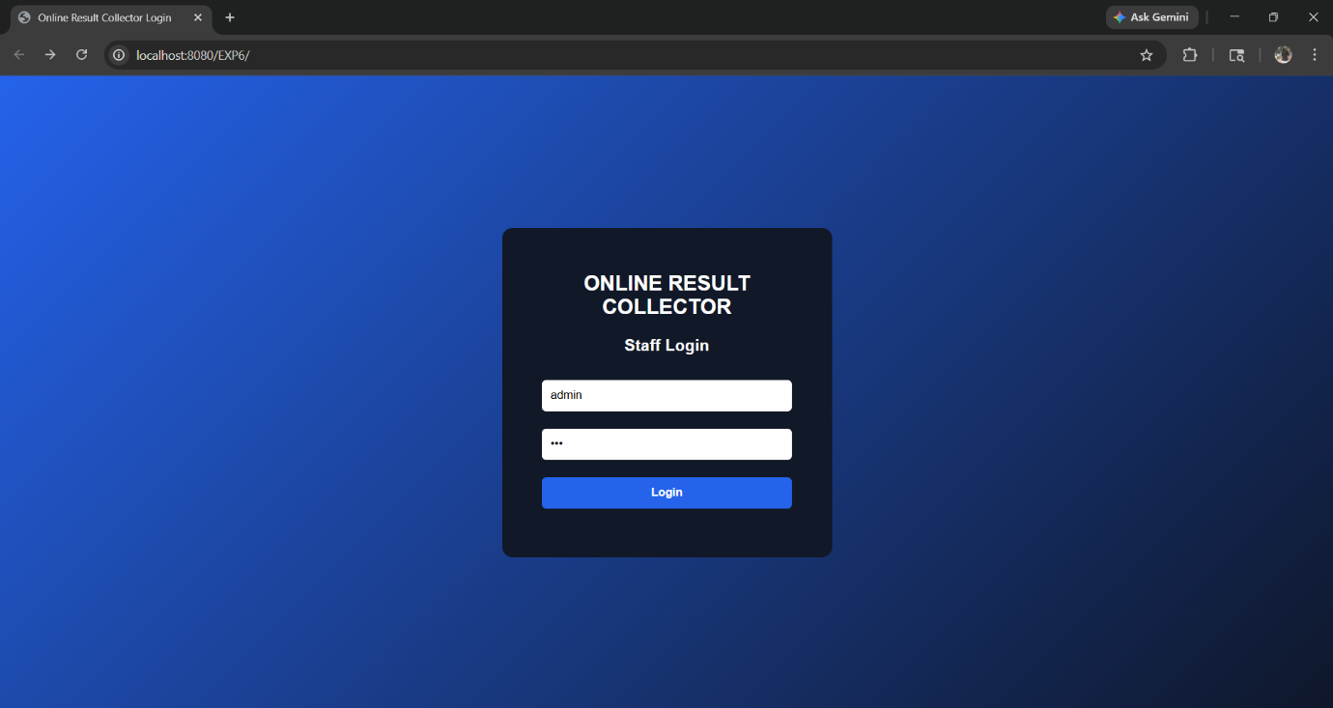

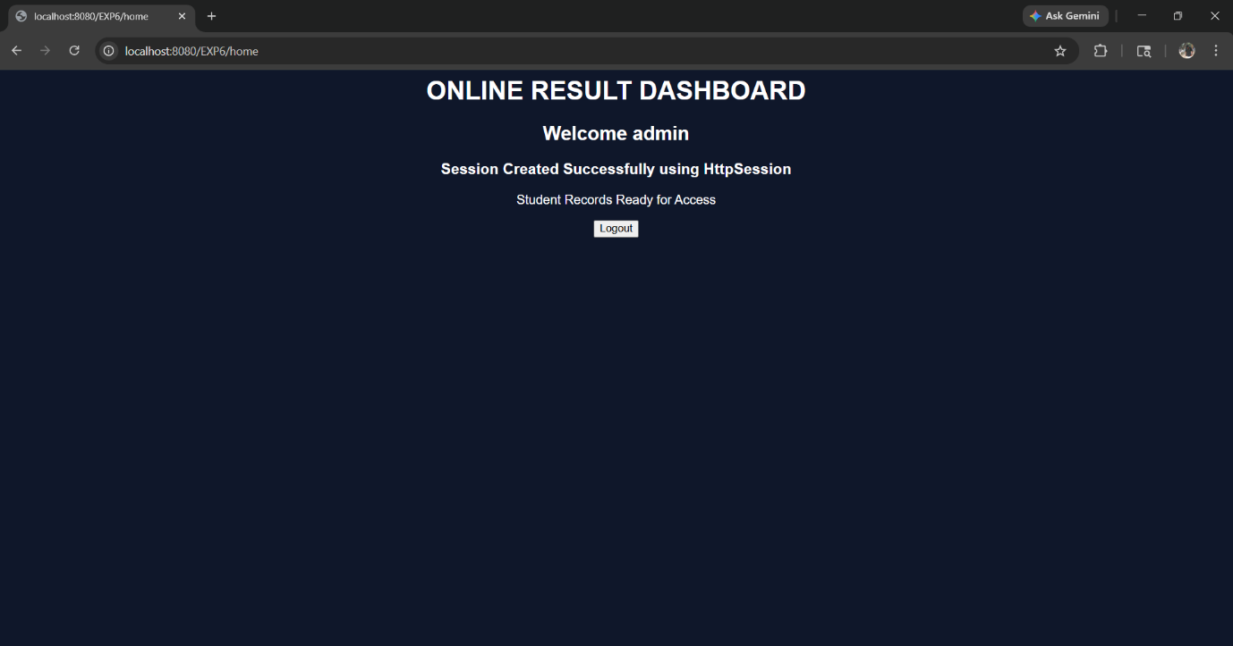

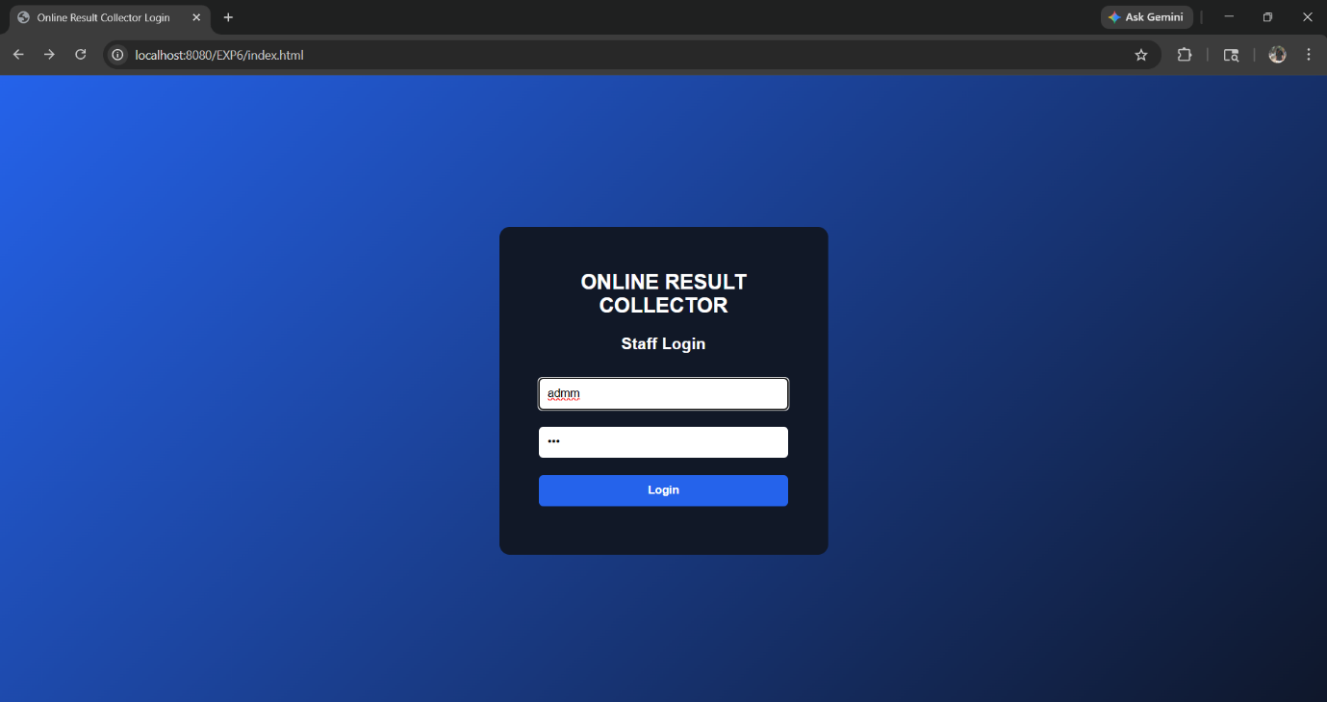
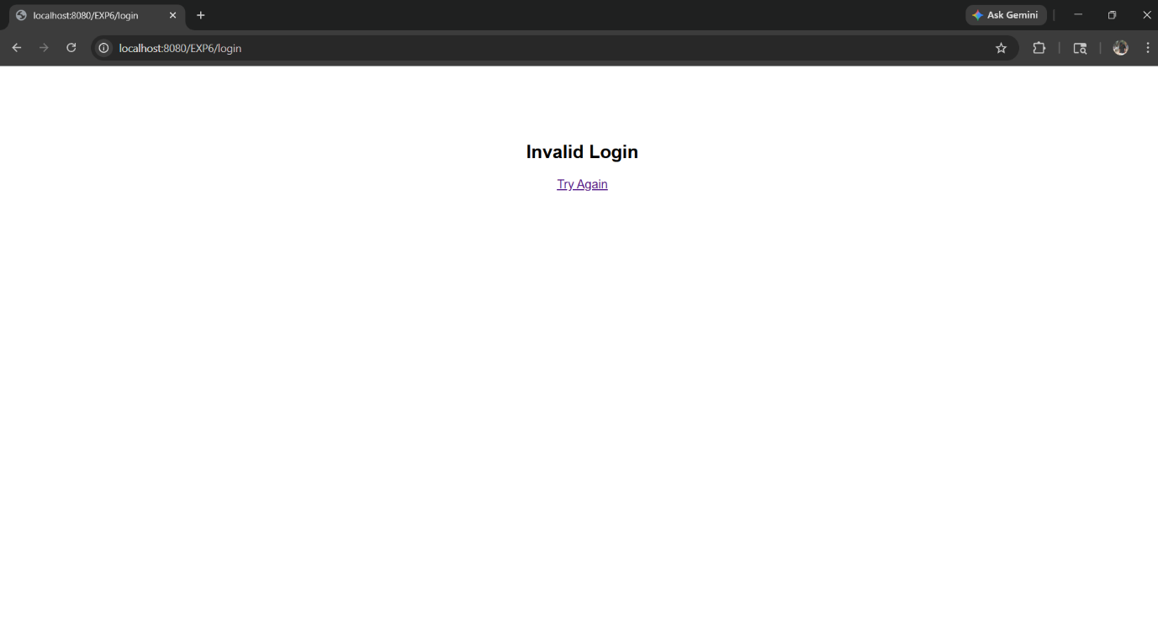

RESULT:
A simple login system is created where the user's session is tracked by a servlet to demonstrate session tracking using HttpSession.

